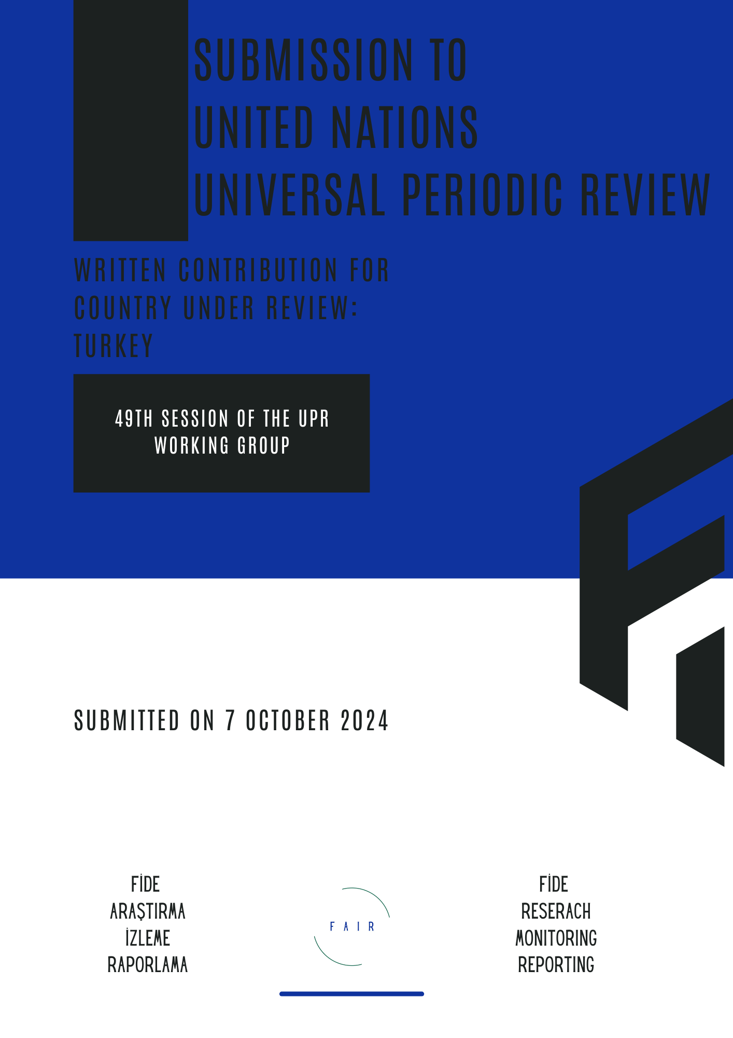


FAIR - Fide Research Monitoring Reporting
FAIR is a human rights organisation specialising in the reliable collection, analysis, and reporting of data on human rights violations in Turkey. With specific expertise in developing sound data collection methodologies, FAIR ensures the accuracy, consistency, and credibility of its findings. The organisation tailors its data collection methods to local contexts and sensitivities, ensuring a clear and accurate portrayal of the extent of human rights violations.
In Turkey, the collection and analysis of human rights-related statistics face several challenges. Data on issues like freedom of expression, peaceful assembly, arbitrary detention and police brutality, torture and ill-treatment, violence against women, and minority rights are often incomplete, inconsistent, or difficult to access due to legal and political constraints. This lack of reliable data hampers efforts to understand the full scope of violations and limits the ability of civil society organisations to advocate effectively for change.
FAIR addresses these shortcomings by producing detailed reports that meet international standards, ensuring that gaps in data collection are filled with reliable, evidence-based documentation. These reports are submitted to international human rights mechanisms and intergovernmental organisations, helping Turkey’s human rights situation gain greater visibility and allowing global bodies to hold Turkey accountable to its obligations under international law.

Introduction
- Turkey received a total of 36 recommendation regarding right to peaceful assembly -17 during the 3rd, 16 during the 2nd, and 3 during 1st cycles. While 23 of the recommendations were supported by Turkey, remaining 13 were only noted. When we analyse the supported recommendations, they are mainly limited to the right to peaceful assembly. When the recommendation includes references to LGBTIQ+ communities or anti-terror legislation or Venice Commission & ECtHR, Turkey tends not to support the recommendation. The recommendations urged Turkey to lift all existing restrictions on peaceful assemblies and to dismiss any unlawful charges and sentences imposed on participants. These recommendations emphasise the importance of ensuring that individuals are free to exercise their right to peaceful assembly without fear of repression or retaliation. By doing so, Turkey would take meaningful steps toward aligning its domestic laws and practices with its international obligations, fostering a more open and democratic society where freedom of expression and assembly are fully respected.
- According to the Implementation Report on the 3rd Judicial Reform Strategy (2019-2023), no meaningful steps have been taken concerning the right to peaceful assembly. In fact, this right is conspicuously absent from Turkey's legal and judicial reform strategies. On the contrary, obstacles to the freedom of peaceful assembly continue to persist across the country. Following the end of the state of emergency (OHAL), amendments to the Provincial Administration Law have granted provincial governors sweeping powers, which have significantly restricted the exercise of this right. In many provinces, blanket bans on all kinds of meetings and demonstrations have been imposed, with some lasting for months or even years.
- Particularly concerning are the bans on peaceful assemblies organised by LGBTIQ+ communities, students and young activists, and women’s groups. Despite their constitutional right to assemble, these groups face consistent restrictions, with all events and demonstrations being systematically prohibited. The government’s failure to reform these laws and practices shows a clear disregard for its international commitments, as the right to peaceful assembly remains severely undermined in Turkey. This situation raises concerns not only about the lack of progress in human rights reforms but also about the increasing trend toward suppressing dissenting voices.
- On 16 December 2020, the Law on the Prevention of Financing the Proliferation of Weapons of Mass Destruction was passed, taking effect on 31 December 2020. The government capitalised on international pressure to combat terrorism financing as a pretext to introduce amendments to unrelated laws, further stifling dissent. As part of this omnibus law, restrictive changes were made to two key laws governing civil society: the Law on Associations and the Law on Aid Collection. These amendments sparked significant backlash from civil society organisations and were widely criticised by international and regional human rights bodies, as well as rule of law mechanisms. It is clear that these reinforcements in the legal plane serve to curb rights and freedoms, as well as to consolidate the climate of fear and intimidation, to stifle rights defenders and non-governmental organizations and to further strain their work.
- Despite its international obligations, Turkey has consistently failed to provide detailed and reliable data on key human rights issues. In spite of ongoing calls for greater transparency and accountability, the government has not offered comprehensive data or interpretations of legally binding documents concerning fundamental rights, particularly in areas such as freedom of expression, peaceful assembly, arbitrary detention, police brutality, and torture, ill-treatment. This data gap undermines Turkey's international commitments and hampers the ability of international bodies and civil society to accurately assess the extent of human rights violations in the country.
- In the field of freedom of expression and one of its forms of manifestation peaceful assembly, Turkey’s restrictive laws and government practices have led to widespread censorship and suppression of dissent. However, reliable data on the number of individuals prosecuted or convicted for exercising these rights is often unavailable. The authorities either fail to release detailed reports or provide vague, incomplete information, making it difficult to track the scope of these violations. Similarly, in cases of arbitrary detention -particularly following the 2016 attempted coup- there is little transparency regarding the number of people detained without due process, with the government often labelling such cases as matters of national security, further obscuring the statistics.
- Regarding police brutality and torture and ill-treatment, although Turkey is obligated to uphold international standards, data on the prevalence of these abuses is sparse. Allegations of police violence during peaceful protests and incidents of torture in detention centres are frequent, yet official data documenting these claims is either not published or insufficiently detailed to allow for meaningful analysis. The absence of reliable statistics in these areas severely hinders accountability and fosters an environment where abuses can occur with impunity.

Peaceful Assembly
- Turkey consistently attempts to present itself to the international community as a nation that upholds and facilitates the right to peaceful assembly. In various reports and statements to international bodies, the government emphasises its legal framework that guarantees freedom of assembly, citing isolated examples of protests or gatherings that were allowed to proceed. Official narratives often stress the existence of mechanisms designed to safeguard these rights and claim that restrictions are only imposed in the interest of public safety or order. However, these claims often conflict with on-the-ground realities, where peaceful assemblies are frequently met with excessive police force, arbitrary detentions, and legal proceedings against participants. By selectively highlighting certain events and downplaying or justifying the suppression of others, Turkey seeks to convince the global community of its commitment to democratic principles, while in practice, it often undermines the very rights it claims to protect.
- One of the most striking examples of this approach can be seen in Turkey’s second periodic report to the UN HRC under the section on “Meetings and Demonstrations.” According to the data provided by the government, the total number of participants in meetings and demonstrations exceeds half the population. From 2016 to 2021, the average number of “protests/activities” reported is around 40,000 annually, even during the global pandemic, despite a decline in participation. However, as is often the case, Turkey fails to provide any breakdowns regarding the nature of these protests or activities. It is evident that the government includes political party rallies, public concerts, opening ceremonies, and government-sponsored gatherings in these figures. Therefore, Turkey must provide detailed information on the specific nature of these protests and activities. Accurate data and statistics are essential for a reliable analysis of the situation regarding protests.
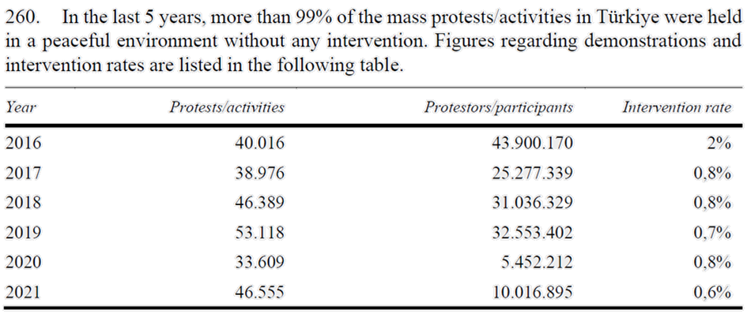
The data provided by Turkey to the UN HRC on protests and activities is statistically irrelevant and offers little value for meaningful analysis.
- Another significant issue related to data and statistics on peaceful assemblies is the number of bans on meetings and demonstrations issued by provincial governors. These blanket bans often cover all protests or activities within the province. For example, in the province of Van, such bans have been renewed every 15 days and have effectively remained in place year-round for nearly 6 years. The government should also disclose data on individual bans of peaceful assemblies. These figures are essential to provide a more accurate and transparent understanding of the state of the right to peaceful assembly in the country.
- According to the data compiled by FAIR, since 2018, in 179 provinces governors issued blanket bans on meetings and demonstrations. In 2024 in 20 different provinces all meetings and gatherings were banned simultaneously following the final decision in the infamous Kobane Trial. At least 3,721 meetings, gatherings, and press statements were intervened and/or dispersed by the police -frequently by excessive use of force and tear gas or other agents-, a total of 813 events, exhibitions, theatre plays, and press statements were banned or prevented, and finally at least 25,861 persons/demonstrators/protesters were detained during the police interventions. The total number of detainees also include 319 children.

 | 2018 | 2019 | 2020 | 2021 | 2022 | 2023 | 2024 | Total
Number of provinces where actions and events are banned | 20 | 24 | 36 | 26 | 28 | 22 | 23 | 179
Number of banned/prevented events, performances, plays, concerts, etc | 114 | 197 | 113 | 118 | 128 | 96 | 47 | 813
Number of meetings and assemblies intervened | 608 | 1,149 | 753 | 334 | 544 | 223 | 110 | 3,721
Number of people detained during meetings and assemblies | 3,720 | 4,371 | 2,123 | 3,677 | 5,764 | 4,141 | 2,065 | 25,861

- Turkey’s second periodic report reveals a striking ability to artfully twist the truth, moulding it to fit its narrative while obscuring the realities of its actions. In the section titled “Meetings and Demonstrations,” the government cites three examples -namely the “Pride Parade,” “Saturday Mothers,” and “International Women’s Day”- to support its claim of fostering an environment where all groups can exercise their right to peaceful assembly without restrictions. However, it is the same government that actively suppresses these peaceful gatherings through the use of excessive police presence and force. Moreover, participants in these assemblies are often met with legal charges and court cases for exercising their constitutional rights. For instance, the case against the Saturday Mothers, initiated after their 700th-week vigil, continues despite a Constitutional Court ruling acknowledging the violation of their rights.
- Following Turkey's withdrawal from the Istanbul Convention on 20 March 2021 with the Presidential Decree, women who peacefully protested the decision in almost all provinces of Turkey were fined, detained and prosecuted. 8 March Women's Day demonstrations continued to protest Turkey's decision to withdraw from the Istanbul Convention.
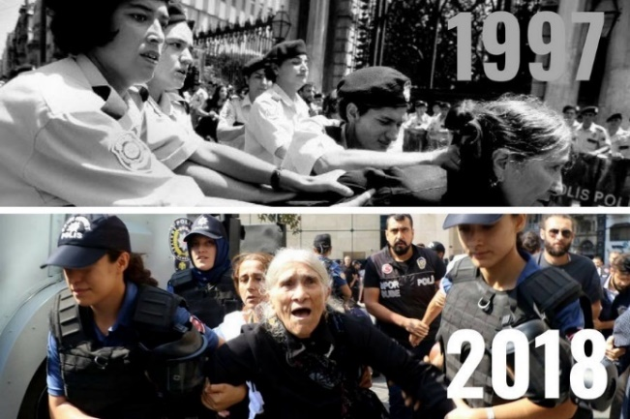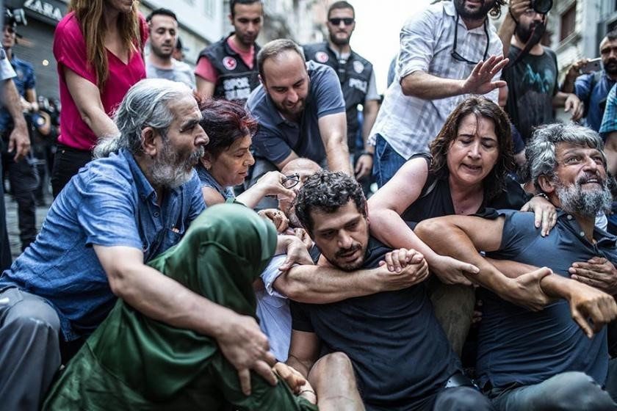
Detention of Saturday Mother Emine Ocak in 1997 and 2018. [on the left] and police intervention to MPs and demonstrators on the day of 700th vigil. [on the right]
- The Saturday Mothers, a group of relatives of those forcibly disappeared in Turkey during the 1980s and 1990s, have been holding peaceful weekly vigils since 1995 to demand justice and accountability for their missing loved ones. Despite the non-violent nature of their gatherings, the state has repeatedly banned their protests, particularly in recent years, and subjected the participants to brutal police intervention. In 2018, on the 700th week of their vigil, the group was violently dispersed, with many, including elderly participants, detained by force. These actions reflect the government’s increasing intolerance of dissent and its disregard for the right to peaceful assembly, as the demands for truth and justice by the Saturday Mothers are met with repression rather than dialogue. There are still 2 separate on-going court cases against the members of the Saturday Mothers related to the vigils on the 700th week and 950th week on the allegations of staging an illegal demonstration.
- 8 March Women’s Day in Turkey has become a significant occasion for advocating women’s rights, yet it is frequently marred by state-imposed restrictions and police intervention. In recent years, despite peaceful intentions, marches and demonstrations held to commemorate International Women’s Day have been met with harsh crackdowns, particularly in major cities like Istanbul. Authorities often cite security concerns to justify bans on gatherings, and protesters are met with police barricades, tear gas, and detentions. The state’s heavy-handed approach has overshadowed what is meant to be a day of empowerment and solidarity for women, with the emphasis shifting from celebration to resistance against the systemic suppression of women’s voices.

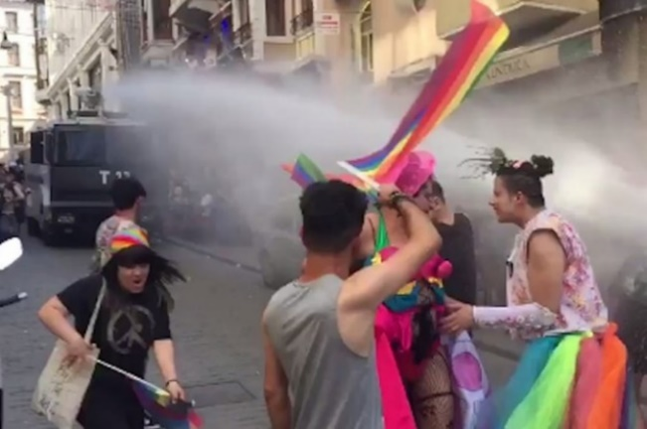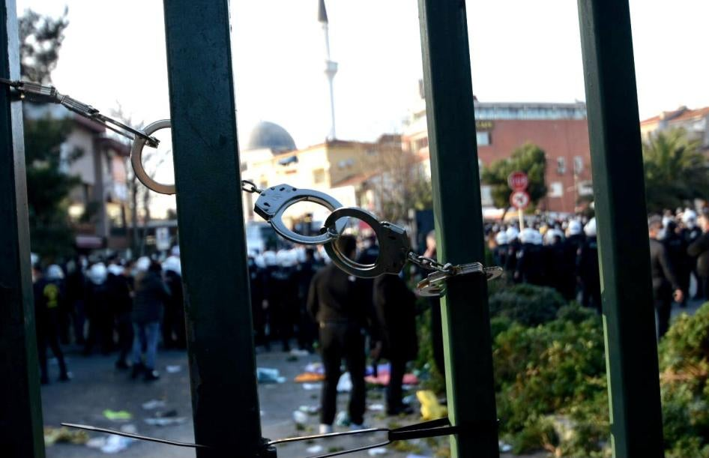
Police intervention to Pride March on İstiklal Avenue in İstanbul [on the left] and Boğaziçi University gate locked with handcuffs by the police to prevent entrance of students [on the right]
- Similarly, LGBTQ+ Pride marches in Turkey have faced increasing repression, particularly since 2015 when Istanbul’s Pride Parade, once one of the largest in the region, was banned for the first time. Subsequent attempts to hold Pride events have been met with aggressive police responses, including the use of tear gas, rubber bullets, and mass arrests. Government officials often claim that these bans are imposed for reasons of “public safety” or to protect public morality, reflecting the broader climate of hostility towards the LGBTQ+ community. The continued repression of Pride events highlights Turkey’s troubling trajectory away from protecting LGBTQ+ rights and towards increased marginalisation and criminalisation of the community. For instance, among many others, the court case launched against Boğaziçi University students in connection with a pride march in 2021 on the university campus is still on-going.
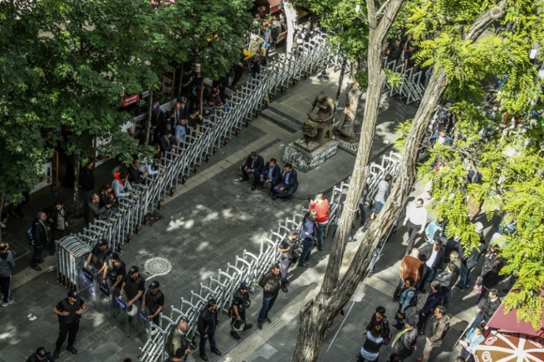
Human Rights Statue in Ankara has been in detention for more than a year between 2017 and 2018 to prevent any peaceful assemblies, press statements, and gatherings in Ankara.

Recommendations
Amend local legislation in line with international standards
Recommend that Turkey remove all barriers to the right to peaceful assembly, allowing individuals and groups to freely organise and participate in public demonstrations without fear of arbitrary bans, excessive force, or legal reprisals. The government should also drop existing charges against peaceful protesters and ensure that any future restrictions fully comply with international human rights standards.
Publishing Detailed Statistics with Breakdowns and Addressing CSO Requests:
Recommend that Turkey publish detailed statistics with comprehensive breakdowns on key human rights issues, including freedom of expression, peaceful assembly, arbitrary detention, police brutality, and torture, ill-treatment. This should involve transparent reporting on the nature and outcomes of legal and administrative processes affecting these areas.
Engagement with Civil Society Organisations:
Encourage Turkey to engage more actively with CSOs in the development and implementation of human rights policies. This engagement should include meaningful consultation with diverse groups to ensure that their perspectives and needs are adequately represented and addressed. This approach will enhance accountability, provide a clearer picture of human rights conditions, and facilitate more effective monitoring and improvement of human rights protections.
Regular and Comprehensive Reporting:
Advise Turkey to submit regular and comprehensive reports to international human rights bodies and mechanisms, including detailed information on the implementation of human rights protections.

Excluding repeated multiple blanket bans. These bans are usually enforced for 15 days and extended on a regular basis in certain provinces like Van and Mardin.
The total number of detainees is based on publicly available information, news, FAIR network. We should remind that the numbers are minimum we could reach. For instance, in 2019, we can validate detention of 225 persons during meetings staged in February. But, according to the official numbers published by the Ministry of Interior Affairs a total of 735 persons were detained in connection with the same demonstrations. And the ministry does not publish similar statistics regularly. Therefore, the real number of detainees must be a lot higher than this.

